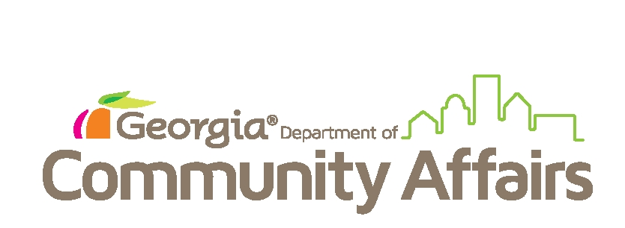
GEORGIA DEPARTMENT OF COMMUNITY AFFAIRS
Notification of HUD COVID-19 Waivers to Participants and Owners

On April 10, 2020, the U.S. Department of Housing and Urban Development (HUD) released a series of temporary waivers and alternative methods due to COVID-19 that Georgia Department of Community Affairs (DCA) has adopted. These temporary waivers will allow DCA to limit contact with residents and participants and to continue housing families and keeping families in their home. As a result, below is the list of temporary waivers DCA has adopted:

- Self-Certifications During Annual and Interim Reexaminations:
Accept self-certifications to verify family income, assets, and expenses when a family is unable to obtain third party verification of such due to Covid-19. The resident may provide this verification by email, fax or regular mail.
This waiver is available until 12/31/21.
How does this waiver affect you?
Current regulations prescribe a verification hierarchy that DCA must follow when requesting information to verify information provided by the family. If you are unable to provide the required information, this waiver allows us to move forward with your Annual or Interim reexamination based on the information you provide. However, the information you provide can later be re-verified and you may be held responsible for any discrepancies. Therefore, please remember to provide complete and accurate information at all times.

- Voucher Oral Briefing
Allows alternative methods to conduct required voucher briefing (e.g., telephone, virtual meetings, etc.).
How does this waiver affect you?
Current regulations require that we inform you about the program through an oral briefing and through written information. This waiver allows us to comply with that requirement by providing you information over the phone, online, or through other alternative methods in order to not delay the issuance of your voucher.

- Project-Based Voucher Pre-HAP Contract Inspections
Allows owner to certify that there are no life-threatening deficiencies. If provided by owner, DCA will conduct a follow-up within one-year of the certification date.
How does this waiver affect you?
Current regulations require that DCA inspect a unit prior to entering into a Project-Based Housing Assistance Payment (HAP) contract. DCA continues to perform initial inspections using protective measures recommended by the Center for Disease Control (CDC). However, DCA is implementing this waiver to reserve its discretion and at its sole-discretion to not require the initial inspection and allow the move-in based on the owner’s certification that there are no life-threatening deficiencies. However, in all cases where an exception is made, DCA will inspect the unit within one year of the certification.

- Self-Certifications at Eligibility Determination
Accept self-certifications to verify family income, assets, and expenses when a family is unable to obtain third party verification of such due to Covid-19. The resident may provide this verification by email, fax or regular mail. This waiver is available until 12/31/21.
How does this waiver affect you?
Current regulations prescribe a verification hierarchy that DCA must follow when requesting information to verify information provided by the family. If you are unable to provide the required information, this waiver allows us to move forward with your Annual or Interim reexamination based on the information you provide. However, the information you provide can later be re-verified and you may be held responsible for any discrepancies. Therefore, please remember to provide complete and accurate information at all times.

