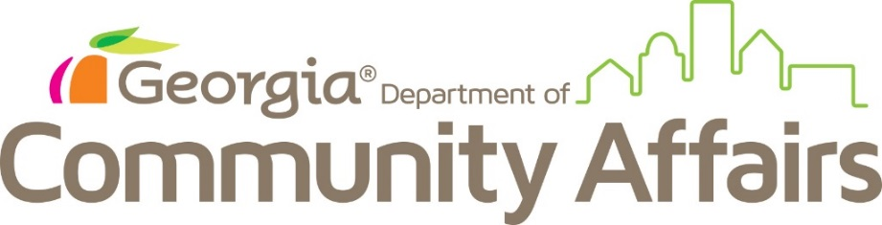
FOR IMMEDIATE RELEASE

Christopher Nunn, Commissioner

The Georgia Commission for Service and Volunteerism announces $3.4M in 2018 AmeriCorps grants
Funding will support 489 AmeriCorps members across the state

Atlanta, GA (August 1, 2018) – The Georgia Commission for Service and Volunteerism (GCSV), the Governor-appointed state service commission housed within the Georgia Department of Community Affairs (DCA), announced today that Georgia has received $3,442,262 in AmeriCorps funding from the Corporation for National and Community Service (CNCS), the federal agency for volunteering and service programs.

“This program is a win-win for Georgia – helping our communities and helping our young people,” said DCA Commissioner Christopher Nunn. “AmeriCorps embodies the spirit of service that is an intangible but invaluable resource for our communities. I’m proud of the work that GCSV does to promote giving back and to encourage young people to be more involved in their local communities.”

The federal investment includes 20 AmeriCorps grants that support 489 AmeriCorps members working for nonprofits, schools and city governments. As part of their service, these AmeriCorps members will help tackle some of the toughest problems in Georgia: tutoring students who may be at risk of failing, helping veterans to receive the services they need, providing a safe and productive environment for homeless youth, teaching our citizens about environmental stewardship, providing services to the disabled, and contributing to the overall quality of life for Georgians.

Below is a listing of 2018 AmeriCorps grants in Georgia:
City of Roswell | $ 89,709
New American Pathways | $ 313,355
The University of Georgia | $ 492,756
Vessel Community Ministries Inc. | $ 63,378
One World Link | $ 72,630
Leap Year Inc. | $ 88,882
Communities in Schools of GA | $ 186,524
Covenant House Georgia, Inc. | $ 148,232
Baldwin County School District | $ 59,387
Clayton State University | $ 152,963
Extra Special People | $ 82,113
Jekyll Island State Parks Authority | $ 332,152
Northwest Georgia Healthcare Partnership Inc. | $ 149,311
The Scholarship Academy Inc. | $ 73,052
Youth Villages Inner Harbour Campus | $ 212,288
Georgia State University Research Foundation Inc. | $ 193,637
United Way of Metro Atlanta | $ 180,596
Relay Georgia School of Education | $ 25,000
Hands on Atlanta | $ 462,797
Teach for America | $ 63,500

“We are grateful to the Corporation for National and Community Service for this investment in Georgia,” said Linda Thompson, Executive Director of GCSV. “The organizations receiving these funds have demonstrated a passion for improving the lives of our citizens, and thousands will benefit from this investment in education, environmental stewardship and the overall wellbeing of Georgians across the state.”

Organizations are currently recruiting for AmeriCorps members to begin service this fall. AmeriCorps members typically receive a modest living stipend and a Segal AmeriCorps Education Award, or scholarship, upon completion of their service. The award can be used to pay for future education costs or to pay back student loans. Those interested in serving can learn more by visiting americorps.gov/join.

Beginning this fall, AmeriCorps members serving in Georgia will join more than 80,000 AmeriCorps members serving across the country in approximately 21,600 locations. These members help communities tackle pressing problems while mobilizing millions of volunteers for the organizations they serve.Since the program’s inception in 1994, more than one million men and women have served in AmeriCorps, delivering more than 1.4 billion hours of service and earning more than $3.3 billion in education scholarships to pay for college or pay back student loans. Over $1 billion of this scholarship funding has been used to pay back student loan debt.

About the Georgia Commission for Service and Volunteerism
The Georgia Commission for Service and Volunteerism is part of the Georgia Department of Community Affairs. Its mission is to promote service and volunteerism in Georgia through AmeriCorps national service grants, community volunteer recognition, and support of local volunteer organizations and efforts. For more information, visit www.americorpsga.org.
About the Georgia Department of Community Affairs
The Georgia Department of Community Affairs (DCA) partners with communities to create a climate of success for Georgia’s families and businesses through community and economic development, local government assistance, and safe and affordable housing. Using state and federal resources, DCA helps communities spur private job creation, implement planning, develop downtowns, generate affordable housing solutions, and promote volunteerism. DCA also helps qualified low- and moderate- income Georgians buy homes, rent housing, and prevent foreclosure and homelessness. For more information, visit www.dca.ga.gov.

