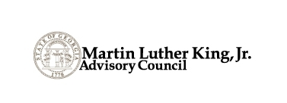

Thursday, March 22, 2018

2:30 p.m. – 3:30 p.m.

Conference Call

CALL-IN INFORMATION
Phone Number: (515) 603-4905
Access Code: 1059335#

AGENDA

- Call to Order - Welcome Guests Chairman Emanuel Jones
- Approval of Minutes Chairman Emanuel Jones

- Planning for April 4, 2018 Program at Stone Mountain

- Chairman’s Report Chairman Emanuel Jones
  - Discussion of Display at Capitol
  - Discussion of Bell Tower at Stone Mountain

- Committee Reports

- Old Business

- New Business

- Set Future Meeting Date/Time

- Adjournment

*Note: Bylaws call for Council’s Annual meeting to be held in July.

