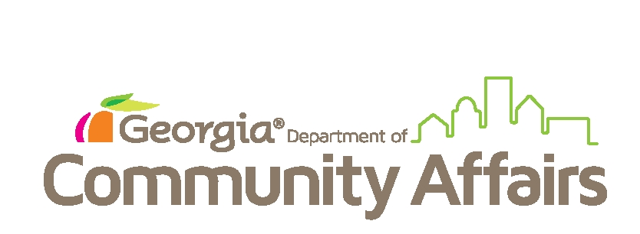

Below is an alphabetical listing of all local authorities registered with the Georgia Department of Community Affairs as of November 6, 2020, in accordance with OCGA § 36-80-16. This listing includes authorities competing FY2020 AARF, due dates are six months from the authority’s fiscal year end.
This list is updated and posted on Friday afternoons. Any questions or follow-up information requests should be sent to DCA.Research@dca.ga.gov and a member of the research staff will respond ASAP.

City of Claxton Downtown Development Authority
Development Authority of Worth County
Downtown Development Authority of Sylvester
Housing Authority of Savannah
Housing Authority of the City of Sugarhill, Georgia
Sylvester Development Authority
Worth County Economic Development Authority

