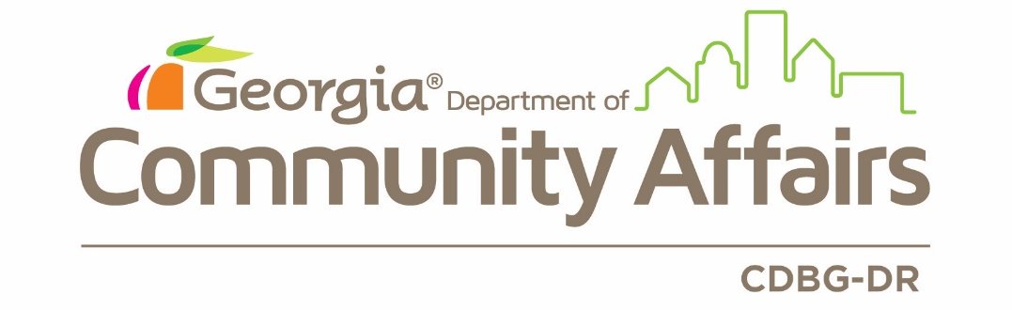

Procurement Policy
A: BACKGROUND
In accordance with 24 CFR 570.489(g), DCA has chosen to follow its own procurement policies and procedures for procurement of goods and services that is paid for in whole or in part with CDBG-DR funds. For subrecipients, the following policies and procedures are established to ensure full and open competition in the procurement of goods and services when CDBG-DR funds are used, in whole or in part, for the implementation of CDBG-DR projects or programs at the local level.
Note that DCA’s procurement policies and procedures implement the requirements of 24 CFR 570.489 (g) for its subrecipients including:
- Full and open competition
- Identification of Methods of Procurement and their applicability
- Prohibition of cost plus a percentage of cost and percentage of construction costs methods
- Assurance that all purchase orders and contracts include any clauses required by Federal statutes, Executive orders, and implementing regulations
- Subrecipient and contractor determinations shall be made in accordance with the standards in 2 CFR 200.330.
- Standards of conduct governing employees engaged in the selection, award or administration of state contracts. Standards for state employees can be found at: Georgia Procurement Manual, Department of Administrative Services, Section I.4.4 Ethical and Professional Conduct, Published May 2018. Section I.4.4 is included as Appendix A to this document.
The subrecipients must include an evaluation of the cost or price of the product or service or DCA will impose 2 CFR 200.318 through 2 CFR 200.326. As detailed in Section B.4.e.
Subrecipients are also subject to the guidelines included in Federal Register Notices 83 FR 5844 and 83 FR 40314, and any futures notices related to this award.
B: STANDARDS
- Subrecipients may use their own procurement regulations which reflect applicable Federal, State, and Local laws, rules and regulations provided that all procurements made with CDBG-DR funds meet the following standards:
  - CDBG-DR Subrecipients must maintain a contract administration system which ensures that contractors perform in accordance with the terms, conditions, and specifications of their contracts or purchase orders.
  - CDBG-DR Subrecipients must maintain a written code of standards of conduct governing the performance of their employees engaged in the award and administration of contracts. No employee, officer or agent of the CDBG-DR Subrecipient shall participate in selection, or in the award or administration of a contract supported by CDBG-DR funds if a conflict of interest, real or apparent, would be involved.
- Conflict of Interest: Such a conflict would arise when there is a financial or other interest in the firm selected for award by:
    - The employee, officer or agent,
    - Any member of his or her immediate family,
    - His or her partner, or
    - An organization which employs, or is about to employ, any of the above.
The Subrecipient’s officers, employees, or agents will neither solicit nor accept gratuities, favors or anything of monetary value from contractors, potential contractors, or parties to sub-agreements. The Subrecipient may set minimum rules where the financial interest is not substantial or the gift is an unsolicited item of nominal intrinsic value. To the extent permitted by State or Local Law or regulations, such standards or conduct will provide for penalties, sanctions, or other disciplinary actions for violations of such standards by the Subrecipient’s officers, employees, or agents, or by contractors or their agents.
- It is national policy to award a fair share of contracts to small and minority business firms. Accordingly, affirmative steps must be taken to assure that small and minority businesses are utilized where possible as sources of supplies, equipment, construction and services. Affirmative steps shall include the following:
  - Including qualified small and minority businesses on solicitation lists.
  - Assuring that small and minority businesses are solicited whenever they are potential sources.
  - When economically feasible, dividing total requirements into smaller tasks or quantities so as to permit maximum small and minority business participation.
  - Where the requirement permits, establishing delivery schedules which will encourage participation by small and minority business.
  - Using the services and assistance of the Small Business Administration, the Office of Minority Business Enterprise of the Department of Commerce and the Community Services Administration as required.
  - If any sub-contracts are to be let, requiring the prime contractor to take the affirmative steps a. through e. above.
  - Subrecipients shall take similar appropriate affirmative action in support of women's business enterprises.
  - Subrecipients are encouraged to obtain goods and services from labor surplus areas.
- All procurement transactions must be conducted in a manner providing full and open competition. Some situations considered to be restrictive of competition include, but are not limited to:
  - Placing unreasonable requirements on firms to qualify to do business,
  - Requiring unnecessary experience and excessive bonding,
  - Noncompetitive pricing practices between firms or between affiliated companies,
  - Noncompetitive awards to consultants that are on retainer contracts,
  - Organizational conflicts of interest,
  - Specifying only a brand name product instead of allowing an equal product to be offered and describing the performance of other relevant requirements of the procurement, or
  - Any arbitrary action in the procurement process.
- Subrecipients must have written selection procedures that provide, as a minimum, the following procedural requirements:
  - Incorporate a clear and accurate description of the technical requirements for the material, product, or service to be procured. Such description must not, in competitive procurements, contain features that unduly restrict competition. The description may include a statement of the qualitative nature of the material, product or service to be procured and, when necessary, set forth minimum essential characteristics and standards to which it must conform to be satisfactory. Detailed product specifications should be avoided if at all possible. When it is impractical or uneconomical to make a clear and accurate description of the technical requirements, a "brand name or equal" description may be used as a means to define the performance or other important requirements of procurement. The specific features of the named brand that must be met by offerors must be clearly stated.
  - Clearly set forth all requirements which offerors must fulfill and all other factors to be used in evaluating bids or proposals.
  - Awards shall be made only to responsible contractors who possess the potential ability to perform successfully under the terms and conditions of a proposed procurement. Consideration must be given to such matters as compliance with public policy, record of past performance, and financial and technical resources.
  - Proposed procurement actions must be reviewed by Subrecipient officials to avoid purchasing unnecessary or duplicative items. Where appropriate, an analysis must be made of lease and purchase alternatives to determine which would be the most economical practical procurement. To foster greater economy and efficiency, Subrecipients are encouraged to enter into State and local intergovernmental agreements for procurement or use of common goals and services.
Subrecipients must perform a cost or price analysis concerning every procurement action, including contract modifications and change orders, and must only permit allowable costs to be included. Further guidance can be found at 24 CFR 85.36(f). Price must be a selection factor in all procurement actions, with the exception of Architecture and Engineering (A&E) services, so long as no other work is included in the scope of work in the RFQ. If additional services are a part of the procurement, price must be a selection factor.
  - It is considered a change order when the final price is established as preliminary bid then negotiated prior to contract signing. This revised price would be re-subjected to independent cost analysis requirement 24 CFR 85.36(f).
The cost plus the percentage of cost method of contracting shall not be used. In addition, contracts with other public agencies will only allow actual cost to be paid. No profit is allowable when contracting with other public agencies.
  - Subrecipients must maintain records sufficient to detail the significant history of procurement. These records must include, but are not necessarily limited to, information pertinent to rationale for the method of procurement, selection of contract type, contractor selection or rejection, and the basis for the cost or price. Costs must be reasonable. A cost is considered reasonable if, in its nature and amount, it does not exceed that which would be incurred by a prudent person under the circumstances prevailing at the time the decision was made to incur the cost, as further detailed in 2 CFR 200.404.
  - Subrecipients must maintain a contract administration system that ensures that contractors perform in accordance with the terms, conditions, and specifications of their contracts or purchase orders.
  - Time and materials type contracts may not be used without DCA approval. A time-and-materials contract may be used only when the Contracting Officer has determined that no other type of contract is suitable, I.E., it is not possible at the time of placing the contract to estimate accurately the extent or duration of the work or to anticipate costs with any reasonable degree of confidence. The subrecipient must submit a justification to DCA documenting the reasons for time and materials contract, which must also include a ceiling price that the contractor exceeds at his/her own risk. Further guidance can be found at 24 CFR 85.36(b)(10).
- The Subrecipient is also encouraged to take the following steps to further open and fair competition and cost savings:
  - Use Federal excess and surplus property in lieu of purchasing new equipment and property whenever such use is feasible and reduces project costs
  - Use value engineering clauses in contracts for construction projects of sufficient size to offer reasonable opportunities for cost reductions. Value engineering is a systematic and creative analysis of each contract item or task to ensure that its essential function is provided at the overall lower cost.
- A summary of all contracts procured for the CDBG-DR Program must be included in the list of procured contracts made available on the Subrecipient’s website.
- All advertisements for procurement that are subject to Section 3 requirements must include the following Section 3 clause:
“This opportunity is covered under the requirements of Section 3 of the HUD Act of 1968, as amended, 12 USC”
- The Section 3 Solicitation Package must be included in all solicitations for projects that are covered under Section 3 of the HUD Act of 1968. DCA’s Section 3 Policy and Solicitation Package are included in Appendices B and C, respectively. Subrecipients shall reference the National Section 3 Business Registry to find a listing of firms that have self-certified that they meet one of the regulatory definitions of a Section 3 business. This registry is a helpful tool to assistant recipients of HUD funding locate Section 3 businesses within their community. Subrecipients shall not contract with a business that is not in compliance with Section 3.
C: METHODS OF PROCUREMENT
All contracts must be made with responsible contractors who possess the potential ability to perform successfully under the terms and conditions of a proposed procurement. Consideration may be given to such matters as contractor integrity, record of past performance, financial and other technical resources, or accessibility to other necessary resources.
A system for contract administration must be maintained by the Subrecipient to assure contractor conformance with terms, conditions, and specifications of the contract or order, and to assure adequate and timely follow-up of all purchases.
There are five methods of procurement that can be used by Subrecipients, if authorized by locally adopted standards:
1. Micro-Purchases and 2. Small Purchases
Micro-Purchases
Micro-purchase means a purchase of supplies or services using simplified acquisition procedures, the aggregate amount of which does not exceed the micro-purchase threshold. For micro-purchases no solicitation is required. This method of procurement is applicable for supplies or services. The dollar thresholds are:
- Under $2,000 for construction
- Under $10,000 for all other purchases
Small Purchases
Small purchase procedures can be used for procurements under $250,000 (if allowed by local policy) and require that price or rate quotations be obtained from at least three (3) sources. This method is applicable for produced items or non-construction services.
Micro Purchase and Small Purchase procurement methods require price analysis when selecting vendors and suppliers. There are a variety of ways of analyzing price, some of which are illustrated below, but the method and degree of analysis grantees used is dependent on the facts surrounding the particular procurement situation. Price Analysis should be documented in the procurement file.
- Compare competitive prices received in response to the solicitation to each other.
- Compare proposed prices to prices on existing contracts or contracts proposed in the recent past. Be sure to factor in any changing conditions, including market, inflation, material price changes.
- Apply rough approximations and review significant inconsistencies, which may require a deeper look at prices to determine if the items are truly comparable. The types of approximations might include price per pound, per square foot, per hour or other typical unit pricing mechanism.
- Review price lists, catalogs or market prices of similar products to determine the market prices generally available to the public.
3. Sealed Bid Proposals
This method is to be used in all construction contracts in excess of $2,000 or produced or designed items exceeding $250,000. If sealed bids are used, the following requirements apply:
- Bids must be solicited from an adequate number of known suppliers, providing them sufficient response time prior to the date set for opening the bids, for local, and tribal governments, the invitation for bids must be publicly advertised;
- The invitation for bids, which will include any specifications and pertinent attachments, must define the items or services in order for the bidder to properly respond;
- All bids will be opened at the time and place prescribed in the invitation for bids, and for local and tribal governments, the bids must be opened publicly;
- A firm fixed price contract award will be made in writing to the lowest responsive and responsible bidder. Where specified in bidding documents, factors such as discounts, transportation cost, and life cycle costs must be considered in determining which bid is lowest. Payment discounts will only be used to determine the low bid when prior experience indicates that such discounts are usually taken advantage of; and
- Any or all bids may be rejected if there is a sound documented reason.
In order to save time and manage administrative services more efficiently, the Subrecipient will pre-qualify potential bidders. The subrecipient would issue an RFP for interested and qualified contractors. Pre-Qualification criteria is developed by the Subrecipient. The Subrecipient would evaluate each of the responses received to develop a pool of qualified contractors. The Subrecipient must also host a pre-qualified contractor orientation. After this pool of contractors is developed, the Subrecipient will solicit sealed bids from the qualified pool of contractors. More information regarding pre-qualification of contractors may be found in the Homeowner Rehabilitation and Reconstruction Manual.
The processes for homeowners to challenge work performed by contractors are also defined in the Homeowner Rehabilitation and Reconstruction Manual.
4. Competitive Negotiation
Competitive negotiation is a method of procurement where proposals are requested from a number of sources and the Request for Proposal (RFP)/Request for Qualifications (RFQ) is publicized. A fixed-price or cost-reimbursable type contract is awarded, as appropriate. Subrecipients should perform a systematic analysis of each contract item or task to assure adequate service and to offer reasonable opportunities for cost reductions. Competitive negotiation may be used if conditions are not appropriate for the use of formal advertising, such as procuring professional services, multi-task services, or designed items. If competitive negotiation is used for procurement under a grant, the following requirements apply:
- Proposals must be solicited from an adequate number of qualified sources to permit reasonable competition consistent with the nature and requirements of the procurement. The RFP/RFQ must be publicized and reasonable requests by other sources to compete must be honored to the maximum extent practicable. "Solicitation" requests by the Subrecipient must be specifically addressed to a list of more than one potential proposer identified by the City/County. To "publicize" the RFP/RFQ, the Subrecipient must also offer the RFP/RFQ through publication in a newspaper with adequate circulation or publication by other means such that reasonable exposure to potential proposers can be expected.
- The RFP/RFQ must identify all significant evaluation factors, including price or cost where required and their relative importance.
- The Subrecipient must have mechanisms for technical evaluation of proposals received, for determinations of responsible offerors for the purpose of written or oral discussions, and for selection for contract award.
- Award may be made to the responsible offeror whose proposal will be most advantageous to the procuring party, price and other factors considered. Unsuccessful offerors should be notified promptly.
- Subrecipients may use competitive negotiation procedures whereby competitors' qualifications are evaluated, and the most qualified competitor is selected, subject to negotiation of fair and reasonable compensation.
- If "competitive negotiation" is not successful, then the Subrecipient must receive "sole source" approval from DCA before contracting.
5. Non-Competitive Proposals
Non-Competitive or "Sole Source Procurement” requires prior DCA approval and may be considered when:
- The item or service is available from only one source;
- Urgent public need will not allow for the delay caused by advertising;
- Although a number of bids were solicited, only one response was received.
To comply with this method of procurement, the subrecipient government (not the individual or firm proposing to provide services) should:
- Develop an RFP/RFQ which includes an explanation of how proposals will be evaluated, including any “evaluation factors” selected by the applicant.
- Publicize the RFP/RFQ. This is most often accomplished by publishing it in the recipient's "legal organ;” The publication must be at least 30 days prior to the deadline for receipt of proposals.
- Send a letter with copy of RFP to a number of "known providers". RFP’s or RFQ’s should be sent to at least five (5) known providers.
- Documentation must be available that the solicitation was actually sent to providers, such as postal return receipt or email verification of delivery.
- Prepare documentation (file memo, etc.) which evaluates proposals and establishes reasons (based on criteria in RFP/RFQ) for contractual recommendations.
- Consult city or county attorney with above recommendations and proposed contract; and
- Based upon established reasons and attorney's recommendation, obtain full council/commission approval and execute contract. Letter(s) thanking unsuccessful respondents for making a proposal should then be sent. Based on evaluation criteria contained in the RFP, this letter should state reasons why the respondent was not hired.

Documentation Needed for DCA Approval of Sole-Source Contracts
For procurement processes that result in requests for sole source approval from DCA, the procurement process must be fully documented to DCA’s satisfaction before DCA will grant approval, including but not limited to the following:
- A letter from the Chief Elected Official stating that only one proposal/bid response was received and stating that a sole source approval is requested;
- A description of the procurement process;
- A tear sheet of the bid advertisement or RFP/RFQ;
- The list and documentation of mailing or emailing the RFP/RFQ to known providers;
- The local government’s attorney has opined the project was advertised/bid in compliance with all applicable laws, rules and regulations, including the Local Government Public Works Construction Law (O.C.G.A. §36-91 et. seq.); and
- For sealed bid procurements, the local government’s engineer/architect has stated that the one bid response’s prices were reasonable and appropriate based on independent cost estimates.
D. GEORGIA PROCUREMENT REGISTRY
Regardless of the method of procurement, all purchases valued at $100,000.00 or greater are subject to the following requirements:
Newly enacted requirements (effective April 28, 2019) based on the passage of House Bill 322 that adds Code Section 36-80-27 and reads as follows: If a bid or proposal opportunity is extended by a county, municipal corporation, or local board of education for goods, services, or both, valued at $100,000.00 or more, such bid or proposal opportunity shall be advertised by such respective local governmental entity in the Georgia Procurement Registry, as established in subsection (b) of Code Section 50-5-69, at no cost to the local governmental entity. Such bid or proposal opportunity shall be advertised on such registry for the same period of time, as set by ordinance or policy, if any, as the county, municipality, or local board of education advertises bid or proposal opportunities in the official legal organ or other media normally utilized by the local government entity. Each advertisement shall include such details and specifications as will enable the public to know the extent and character of the bid or proposal opportunity.
Newly enacted requirements (effective April 28, 2019) based on the passage of House Bill 322 that amends Code Section 36-91-20(b)(1) and reads as follows: Prior to entering into a public works construction contract other than those exempted by Code Section 36-91-22, a governmental entity shall publicly advertise the contract opportunity. Such notice shall be posted conspicuously in the governing authority's office and shall be advertised on the Georgia Procurement Registry as provided for in Code Section 50-5-69 at no cost to the governmental entity. Such advertisement on such registry shall be for the same period of time specified under paragraph (3) of this subsection. Such notice may be advertised in the legal organ of the county or by electronic means on the website of the governmental entity or any other appropriate websites identified by the governmental entity.
Please see O.C.G.A 36-80-27 for further information.

E. CONTRACT REQUIREMENTS
The Subrecipient must include, in addition to the provisions needed to define a sound and complete agreement, the following provisions in all contracts:
- All contracts must clearly state the period of performance or date of completion.
- Contracts other than micro purchases and small purchases must contain such contractual provisions or conditions which will allow for administrative, contractual or legal remedies in instances where contractors violate or breach contract terms, and they must also provide for appropriate sanctions and penalties.
- All contracts in excess of $10,000 must contain provisions for terminations "for convenience" by Subrecipient, including when and how termination may occur and the basis for settlement. In addition, all contracts must describe conditions under which the contract may be terminated for default as well as conditions where the contract may be terminated because of circumstances beyond the control of the contractor.
- All contracts awarded by Subrecipients and their contractors or sub-grantees having a value of more than $10,000 must contain a provision requiring compliance with Executive Order 11246, entitled "Equal Employment Opportunity", as amended by Executive Order 11375, and as supplemented in the Department of Labor regulations (41 CFR, Part 60).
- All contracts and sub-contracts over $2,000 for construction or repair must include a provision for compliance with the Copeland "Anti-Kickback" Act (18 U.S.C. 874) as supplemented in Department of Labor regulations (23 CFR, Part 3). This act provides that each contractor shall be prohibited from inducing, by any means, any person employed in the construction, completion, or repair of public work, to give up any part of the compensation to which he is otherwise entitled. The Subrecipient must report all suspected or reported violations to DCA.
- All construction contracts awarded by Subrecipients in excess of $2,000 must include a provision for compliance with Davis-Bacon Act (40 U.S.C. 27ato a-7) as supplemented by Department of Labor regulations (29 CFR, Part 5). Under this act contractors shall be required to pay wages to laborers and mechanics at a rate not less than the minimum wages specified in a wage determination made by the Secretary of Labor. In addition, contractors shall be required to pay wages not less often than once a week. The Subrecipient must place a copy of the current Prevailing Wage Determination issued by the Department of Labor in each solicitation and the award of a contract must be conditioned upon acceptance of the wage determination. The Subrecipient must report all suspected or reported violations to DCA.
- Where applicable, all contracts awarded by Subrecipients in excess of $100,000 for construction contracts which involve the employment of mechanics or laborers must include a provision for compliance with sections 103 and 107 of the Contract Work Hours and Safety Standards Act (40 U.S.C. 327-330) as supplemented by Department of Labor regulations (29 CRF, Part 5). Under Section 103 of the Act, each contractor shall be required to compute the wages of every mechanic and laborer based on a standard workday of 8 hours and a standard workweek of 40 hours. Work in excess of the standard workweek is permissible provided that the worker is compensated at a rate of not less than 1 1/2 times the basic rate of pay of all hours worked in excess of 40 hours in the workweek. Section 107 of the Act is applicable to construction work and provides that no laborer or mechanic shall be required to work in surroundings or under working conditions which are unsanitary, hazardous, or dangerous to his health and safety as determined under construction, safety and health standards promulgated by the Secretary of Labor. These requirements do not apply to the purchases of supplies or material or articles ordinarily available on the open market.
- All negotiated contracts (except those of $10,000 or less) must include a provision that DCA, HUD, the Comptroller General of the United States, or any of their duly authorized representatives, shall have access to any books, documents, papers, and records of the contractor which are directly pertinent to a specific grant program for the purposes of making audit, examination, excepts, and transcriptions for 3 years after final payment of the Subrecipient and all pending matters are closed.
- Contracts, sub-contracts and sub-grants of amounts in excess of $100,000 must contain a provision which requires compliance with all applicable standards, orders, or requirements issued under Section 306 of the Clean Air Act (42 U.S.C. 1857(h) or Section 508 of the Clean Air Act (33 U.S.C. 1368). Executive Order 11738, and Environmental Protection Agency regulations (40 CFR, Part 15), that prohibit the use of facilities included on the EPA List of Violating Facilities.
- Contracts must recognize mandatory standards and policies relating to energy efficiency which are contained in the State Energy Conservation Plan issued in compliance with the Energy Policy and Conservation Act (PL 94-163).
- Contracts must recognize the requirement to meet the Green Building Standard for new construction of residential buildings and replacement of substantially damaged residential buildings. To meet this standard, at least one of the following programs must be used: (i) ENERGY STAR (Certified Homes or Multifamily High-Rise), (ii) Enterprise Green Communities, (iii) LEED (New Construction, Homes, Midrise, Existing Buildings Operations and Maintenance, or Neighborhood Development), (iv) ICC–700 National Green Building Standard, (v) EPA Indoor AirPlus (ENERGY STAR a prerequisite), or (vi) any other equivalent comprehensive green building program acceptable to HUD.
- In compliance with 24 CFR 135.9, all Section 3 covered contracts shall include the following clause (referred to as the “Section 3 Clause”):
- The work to be performed under this contract is subject to the requirements of Section 3 of the Housing and Urban Development Act of 1968, as amended, 12 U.S.C. 1701u (section 3). The purpose of section 3 is to ensure that employment and other economic opportunities generated by HUD assistance or HUD-assisted projects covered by section 3, shall, to the greatest extent feasible, be directed to low- and very low-income persons, particularly persons who are recipients of HUD assistance for housing.
- The parties to this contract agree to comply with HUD’s regulations in 24 CFR Part 135, which implement section 3. As evidenced by their execution of this contract, the parties to this contract certify that they are under no contractual or other impediment that would prevent them from complying with the part 135 regulations.
- The contractor agrees to send to each labor organization or representative of workers with which the contractor has a collective bargaining agreement or other understanding, if any, a notice advising the labor organization or workers’ representative of the contractor’s commitments under this section 3 clause, and will post copies of the notice in conspicuous places at the work site where both employees and applicants for training and employment positions can see the notice. The notice shall describe the section 3 preference, shall set forth minimum number and job titles subject to hire, availability of apprenticeship and training positions, the qualifications for each; and the name and location of the person(s) taking applications for each of the positions; and the anticipated date the work shall begin.
- The contractor agrees to include this section 3 clause in every subcontract subject to compliance with regulations in 24 CFR Part 135, and agrees to take appropriate action, as provided in an applicable provision of the subcontract or in this section 3 clause, upon a finding that the subcontractor is in violation of the regulations in 24 CFR Part 135. The contractor will not subcontract with any subcontractor where the contractor has notice or knowledge that the subcontractor has been found in violation of the regulations in 24 CFR Part 135.
- The contractor will certify that any vacant employment positions, including training positions, that are filled (1) after the contractor is selected by before the contract is executed, and (2) with persons other than those to whom the regulations of 24 CFR part 135 require employment opportunities to be directed, were not filled to circumvent the contractor’s obligations under 24 CFR part 135.
- Noncompliance with HUD’s regulations in 24 CFR part 135 may result in sanctions, termination of this contract for default, and debarment or suspension from future HUD assisted contracts.
- Debarment and Suspension (Executive Orders 12549 and 12689)—A contract award (see 2 CFR 180.220) must not be made to parties listed on the government wide exclusions in the System for Award Management (SAM), in accordance with the OMB guidelines at 2 CFR 180 that implement Executive Orders 12549 (3 CFR part 1986 Comp., p. 189) and 12689 (3 CFR part 1989 Comp., p. 235), “Debarment and Suspension.” SAM Exclusions contains the names of parties debarred, suspended, or otherwise excluded by agencies, as well as parties declared ineligible under statutory or regulatory authority other than Executive Order 12549.
- (I) Byrd Anti-Lobbying Amendment (31 U.S.C. 1352)—Contractors that apply or bid for an award exceeding $100,000 must file the required certification. Each tier certifies to the tier above that it will not and has not used Federal appropriated funds to pay any person or organization for influencing or attempting to influence an officer or employee of any agency, a member of Congress, officer or employee of Congress, or an employee of a member of Congress in connection with obtaining any Federal contract, grant or any other award covered by 31 U.S.C. 1352. Each tier must also disclose any lobbying with non-Federal funds that takes place in connection with obtaining any Federal award. Such disclosures are forwarded from tier to tier up to the non-Federal award.
- A non-Federal entity that is a state agency or agency of a political subdivision of a state and its contractors must comply with section 6002 of the Solid Waste Disposal Act, as amended by the Resource Conservation and Recovery Act. The requirements of Section 6002 include procuring only items designated in guidelines of the Environmental Protection Agency (EPA) at 40 CFR part 247 that contain the highest percentage of recovered materials practicable, consistent with maintaining a satisfactory level of competition, where the purchase price of the item exceeds $10,000 or the value of the quantity acquired during the preceding fiscal year exceeded $10,000; procuring solid waste management services in a manner that maximizes energy and resource recovery; and establishing an affirmative procurement program for procurement of recovered materials identified in the EPA guidelines.
- Rights to Inventions Made Under a Contract or Agreement. If the Federal award meets the definition of “funding agreement” under 37 CFR §401.2 (a) and the recipient or subrecipient wishes to enter into a contract with a small business firm or nonprofit organization regarding the substitution of parties, assignment or performance of experimental, developmental, or research work under that “funding agreement,” the recipient or subrecipient must comply with the requirements of 37 CFR Part 401, “Rights to Inventions Made by Nonprofit Organizations and Small Business Firms Under Government Grants, Contracts and Cooperative Agreements,” and any implementing regulations issued by the awarding agency.
E. ASSISTANCE RELATED TO PROCUREMENT MATTERS
Subrecipients are encouraged to contact DCA for assistance in any procurement matter. However, the Subrecipient is the responsible authority under its contracts, without recourse to DCA regarding the settlement and satisfaction of all contractual and administrative issues arising out of procurements entered into, in connection with the CDBG-DR program. Matters concerning violation of law are to be referred to such Local, State or Federal authority as may have proper jurisdiction.
CDBG-DR Contact Information:
By phone: (404) 679-4840
By email: CDBG-DR@dca.ga.gov
By mail: Georgia Department of Community Affairs
Attention: CDBG-DR
60 Executive Park South, NE
Atlanta, GA 30329
Additional Guidance:
The Buying Right CDBG-DR and Procurement: A Guide to Recovery, is a good resource related to procurement. The guide can be found at the following link:
https://www.hudexchange.info/resource/5614/buying-right-cdbg-dr-and-procurement-a-guide-to-recovery/
Additionally, the process for contractor bidding can be read about in further detail in the Homeowner Rehabilitation and Reconstruction Manual. If you do not have a copy of the manual, please contact DCA staff.

Appendix A:
Excerpts from Georgia Procurement Manual, Department of Administrative Services, Section I.4.4. Ethical and Professional Conduct
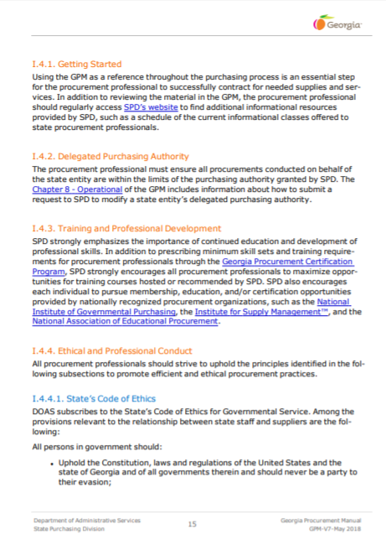
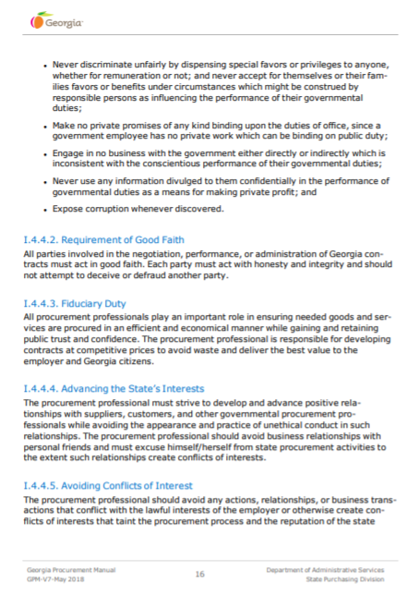
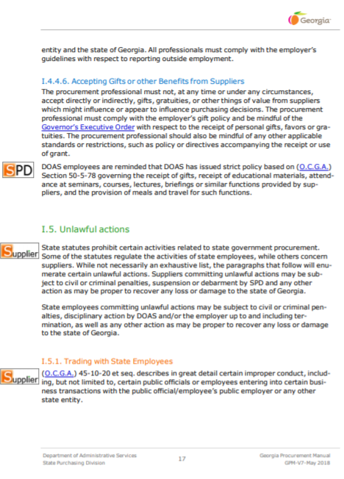

Appendix B:
DCA Section 3 Policy

