Downtown Development
Revolving Loan Fund

SINCE 1999  INVESTMENT  - 212 Awards  - $34.3M DD RLF Investment  - $148.6M Private Investment  - $182.9M Total Project Costs  JOB & BUSINESS CREATION  - 2996 new/retained jobs  - 290 new businesses  DOWNTOWN  REVITALIZATION  - 320 new commercial units  - 236 new residential units  QUESTIONS  Cherie Bennett  DDRLF Program Manager, Office of State Economic Development  (404) 831-2058  cherie.bennett@dca.ga.gov www.dca.ga.gov  February 1, 2023 | Revitalizing and Enhancing Georgia’s Downtowns  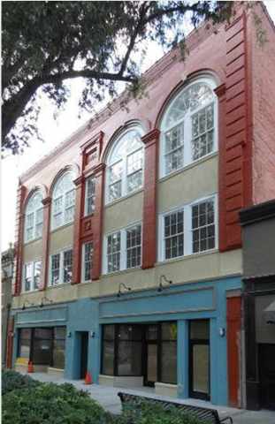  The purpose of the Downtown Development Revolving Loan Fund (DD RLF) is to assist cities, counties and development authorities in their efforts to revitalize and enhance downtown areas by providing below-market rate gap financing to fund capital projects in core historic downtown areas and adjacent historic neighborhoods where DD RLF will spur commercial redevelopment.  Since 1999, this fund has helped finance projects in downtowns across the state, helping property owners, local governments and entire communities rebuild, reuse and preserve pieces of our state’s heritage and history.  The Baldwin Lofts, Milledgeville, GA  Eligible Applicants: Eligible applicants under this program shall be municipalities with a population of 100,000 or less, counties with a population of 100,000 or less proposing projects in a core historic commercial area, and development authorities proposing projects in a core historic commercial area in municipalities or counties with a population of 100,000 or less. The ultimate user of funds may be a private business or a public entity such as a city or development authority.  Loan Amounts: The minimum loan is $50,000 and the maximum loan is $250,000 per project, not to exceed 40% of total eligible project costs.  Eligible Use: Applicants must demonstrate that they have a viable downtown development project and clearly identify the proposed uses of the loan proceeds. Once approved, funds may be used for such activities as: real estate acquisition, development, redevelopment, rehabilitation and new construction; rehabilitation of public buildings (on a limited basis); purchase of equipment and other assets (on a limited basis).  Loan Terms: Interest rates are below-market with Main Street cities currently receiving a 2% rate and all other cities receiving a 3% rate. Repayment period is 15 years with a fifteen-year amortization. Security is usually project collateral and personal guarantees.  Application: Applications are accepted throughout the year. To download a copy of the Initial Project Assessment form, please visit www.dca.ga.gov.  