2024 ARCHITECTURAL MANUAL APPENDIX III
“AMENITIES GUIDE”
TABLE OF CONTENTS

INTRODUCTION

ALL AMENITIES
- General Guidelines

STANDARD SITE AMENITIES
- Community Room / Community Building
- Exterior Gathering Area
- On-site Laundry Facility and/or Washers/Dryers installed in each unit

ADDITIONAL SITE AMENITIES
- Fenced Community Garden
- Equipped Walking Path
- Equipped Playground
- Covered Pavilion with Picnic/barbecue Facilities
- Furnished Arts & Craft /Activity Center
- Equipped Computer Center
- Furnished Exercise / Fitness Center
- Wellness Center

UNIT AMENITIES

ADDITIONAL SENIOR DEVELOPMENT AMENITIES
- Elevators
- Interior Conditioned and Furnished Gathering Areas

AMENITIES GUIDEBOOK PHOTOS

INTRODUCTION:
This guidebook is an outline of minimum standards for site amenities required by the Low-Income Housing Tax Credit (LIHTC) and HOME, NHTF, CDBG-DR, TCAP (GHFA) funding programs and establishes a baseline for the quality of construction and financial investment in amenities. More requirements for unit amenities may be found in the Architectural Manual.

ALL AMENITIES:
- New construction and rehabilitation property amenities must meet accessibility requirements outlined in the DCA Accessibility Manual. For tenant safety and security, exterior amenities should be within view of at least one apartment building.
- Amenity lighting should be sufficient for its purpose (i.e. evening mail collection, etc.), and be directed down to diminish nuisance light.
- Rules posted at all amenities must be in accordance with the Federal Fair Housing Amendments Act.
- Amenities should be usable beyond leasing office hours and on weekends.
- Post permanently affixed signage with hours of operation. and, as applicable, safety guidelines.
- Prior to commencement of construction, the requirements for each QAP project amenity (i.e., furnishings, equipment,) must be clearly delineated (both written and graphically) on the construction drawings provided by the Project Architect (NOTE: For GHFA funded projects this would include the DCA “Review Set” of CDs).

Qualified substitutions may be submitted for approval prior to Application submission; equivalency standards will be applied to amenity substitutions.

STANDARD SITE AMENITIES
All properties must include the following on-site amenities:

Community Room / Community Building
The community gathering room/building should provide a space for tenants to “gather for lounging”, “special events”, “meetings”, “parties”, “classes”, and “workshops”. The space should comfortably accommodate the number of tenants in the community and be designed to meet Minimum State Code requirements for occupant load and means of egress. Signage, as required by UFAS, shall be provided. The room should have windows.

Furnishing must include, but are not limited to:
- Seating Area
- Coffee Table
- Task Lighting

**NO FOLDING FURNITURE ALLOWED**

Suggested furnishings include:

- Television
- Sound System
- Musical Instruments
- Game / Card Table
- Couches

Additional Requirements:
Kitchen and bath facilities intended for tenant use must be accessible. See the DCA Accessibility Manual for further guidance.

Exterior Gathering Area
The exterior gathering area shall provide proper shelter from the elements and be reserved exclusively for the social interaction of the tenants and their guests. Porches may not be used for other purposes, such as a driveway or parking space.

Additional Requirements:
- The gathering area must be covered by a roof

- Must be permanently attached/anchored to a concrete foundation/slab.
- Landscaping
- One bench for every 25 units.
- Exterior Gathering Area must be separate from the Equipped Playground observation area.

Examples of exterior areas that “do not” meet the requirements of this amenity:
- Porte-cocheres
- Carport, driveways, or parking spaces
- Small awnings that can shelter only one person
- Pergolas

On-site Laundry Facility and/or Washers / Dryers installed in each unit
All communities must provide washer/dryer facilities and equipment on site. An onsite laundry is not required if washers and dryers are installed in units and maintained at no additional cost to tenants. Laundry facilities shall be large enough to accommodate the required number of washers and dryers. Laundry facilities must be accessible to the disabled (see the DCA Accessibility Manual for further guidance). NOTE: In addition, for new construction only, all communities must provide washer and dryer “hookups” in each unit.

Signage and Equipment:
- There shall be one washer and one dryer per every 25 units.
- All washers must be Energy Star rated
- All owner-furnished “washers” in mobility units shall be front-loading.
- Each laundry facility must include at least once “accessible” washer (front-loading) and dryer placed in required clear floor spaces.
- Post signage that addresses machine operation, safety guidelines, and hours of operation.

Additional Requirements:
- Free-standing laundry buildings must be within a reasonable walking distance of the residential units.

- The facility must be accessible to the disabled.
NOTE: See the “Accessibility Manual” for additional requirements.
- Access must be provided to this area "beyond" leasing office business hours.
- Laundry facilities, including those within units, must be vented to the exterior, controlling humidity levels to prevent the growth of bacteria, mold, mildew, and dust mite infestations.
- Washers in units must be equipped with a "drain pan or floor drain" as required by the Georgia State Minimum Standard Codes (with Georgia Amendments).

ADDITIONAL SITE AMENITIES
A Properties that have 125 units or fewer must include at least two (2) additional site amenities. Properties with more than 125 units must include at least four (4) additional site amenities.

Fenced Community Garden
A fenced community garden will provide a minimum planting area of 200 square feet. Community gardens, which for various reasons are not used, must be kept. Community gardens that are allowed to deteriorate through management neglect will not be tolerated.

Signage and Equipment:
- Provide a water source within the fenced area of the community garden located near the entrance or to one side of the planting area. The water source should take into consideration best practices for water conservation. Rain barrels may be used, but not as the primary source of water.
- Post rules and safety guidelines at the garden entrance.

Additional Requirements:
- The soil must be properly prepared for planting.
- Gardens shall be surrounded on all sides with a minimum 4’ high fence of weatherproof construction to discourage small children and animals from entering the garden. If pressurized wood is used for fencing or raised beds,

ensure the manufacturer verifies that it is safe to grow edible plants in soil surrounded by their wood product.
- The effects of all contaminants discovered in the Phase I Environmental Assessment must be considered before choosing to build the garden.
- A portion of these plots must be accessible to those with mobility impairments, including reach range limitations. The route to the fenced community garden, garden water source and to the accessible planting area or areas must be paved and meet all accessibility requirements for an accessible route. Accessible planting areas must have accessible reach ranges from the accessible route.

Equipped walking path with exercise stations or sitting areas
The walking path should be a minimum of 500 feet long and 5 feet wide and provide a safe and accessible path for fitness and leisure. Rules and safety guidelines should be posted along entry points to the path.

- Walking surface should provide proper firmness, stability, and slip resistance. Asphalt paving, crushed stone or fines, packed soil, and other natural materials can provide surfaces that are firm and stable and accessible. A surface stabilizer may be needed to create a firm and stable surface. Concrete paths shall have a brushed finish.
- Base material should be laid over a geo-textile fabric to prevent vegetation growth and compacted with the correct moisture content, similar to the preparation of a roadbed.
- Walking paths must be separate from the sidewalks that access parking and buildings and must not disturb more than 1/10th of an acre of wetland.

Equipment (either benches or fitness stations): Benches:
  - There must be at least one bench for every 100 feet of walking path.
  - Benches must have backrests and an armrest at one end of the bench for use by the elderly and disabled.
  - A fully accessible clear floor space measuring 30”x48” minimum shall be provided at one end of each bench.
  - Benches must be secured to the ground or walking path and protected against

ground subsidence.
  - Benches shall be made of a weatherproof material.

Fitness Stations:
  - Provide one piece of equipment per every 100 feet of walking trail.
  - All strength, cardiovascular, flexibility, or balance/coordination equipment must be intended for outdoor use and made of a durable and weatherproof material (see http://www.triactiveamerica.com/).

Equipped Playground
The design of the playground should provide a safe, accessible play area for children of different ages and shall be designed following the guidelines set forth in Publication Number 325, the U.S. Consumer Product Safety Commission’s (CPSC) Handbook for Public Playground Safety. https://www.cpsc.gov/s3fs-public/325.pdf

Signage and Equipment:
- Provide four or more stand-alone pieces of equipment.
- Include equipment for children ages 2-12. Equipment intended for younger children (ages 2-5) must be separated by a buffer zone and have signage.
- A connected multi-piece jungle gym can be used in lieu of the stand-alone pieces if it will provide 7 or more pieces of equipment and must accommodate ages 2-12.
- A minimum of two benches for adult supervision is required. An accessible route is required within the playground area from the accessible entrance to the bench. An accessible space next to the bench is also required.
- Post rules and safety guidelines that include guidance as to the age appropriateness of the equipment.

Additional Requirements:
- In playgrounds intended to serve children of all ages, the layout of pathways and the landscaping of the playground should show the distinct areas for the different age groups.
- Groundcover must be provided as specified in Publication Number 325, the U.S. Consumer Product Safety Commission’s (CPSC) Handbook for Public Playground Safety.
- Equipment intended for younger children (ages 2 -5) must be separated at least by a buffer zone, which may be an area with shrubs or benches. Short fencing is preferable.
- A portion of the playground equipment must be accessible to those with mobility impairments. The route to the playground must be paved and meet all accessibility requirements for an accessible route. See the DCA Accessibility Manual for further guidance.
- Access must be provided to this area "beyond" leasing office business hours.
- Equipped playground needs to be separate from the Exterior Gathering Area.
- Equipment may include but not limited to: seesaws, swings, monkey bars, round abouts, teeter totters, etc.

Covered Pavilion with picnic/barbecue facilities

The pavilion encourages residents to hold community or family reunion type functions. The shelter should be a permanent structure made of weatherproof material and be permanently attached to a concrete foundation/slab.

Signage and Equipment:
- One picnic table for "every 25 units". At least one picnic table shall have an extension that allows clear knee space for handicap access. Picnic tables shall have permanent anchorage to the ground.
  - The picnic tables shall be under the pavilion. For projects with over 150 units, at least six of the picnic tables must be under the pavilion. The remaining required picnic tables must be either under the pavilion or in close proximity to the pavilion.
- One permanent barbeque grill (gas or charcoal) for every 50 units. At least one grill shall be accessible an accessible path and have permanent anchorage to the ground.
- The pavilion area shall have a durable surface with defined edges such as concrete.
- Post rules and safety guidelines for grill use.

Furnished Arts & Craft /Activity Center
The activity center will provide either children or seniors, as appropriate to tenant base, an indoor gathering space for games and craft activities. 200 square feet is the minimum room size. Maintain adequate stock/inventory of equipment and materials.

Signage & Equipment:
- Handicap accessible sink
- Storage for games and craft materials
- Worktables and seating.
- TV with capability to broadcast instructional videos
- One corkboard or dry-erase board

Additional Requirements:
- Access must be provided to this area "beyond" leasing office business hours.

**NO FOLDING FURNITURE ALLOWED AS PRIMARY FURNITURE**

Equipped Computer Center
The computer center, of at least 150 square feet, should provide tenants high-speed access for educational or leisurely web surfing as well as basic software applications to help facilitate personal, educational, and career development. The computer center must be a designated enclosed room.

Signage and Equipment:
- One working computer for every 25 units and WiFi accessibility (replaced every 5 years)
- Computer desk or desk area (folding tables are not allowed)
- Seating: chairs specifically designed for computer use
- One printer at a minimum
- One scanner, at a minimum
- High speed internet access
- Basic word processing and spreadsheet software
- Post rules and guidelines for computer use.

Additional Requirements:
- Appropriate controls to restrict internet surfing must be installed.
- Access must be provided to this area beyond leasing office business hours.
- For larger developments with over 150 units, providing a mix of laptops and desktop computers, there must be a minimum of 6 stationary computers in the computer center.
- Laptops must be held in a safe, monitored location with check-in and check-out procedures posted.

Furnished Exercise / Fitness Center
The exercise/fitness center, of at least 200 square feet, should provide tenants with access to equipment that will improve the fitness and well-being of residents.

Signage and Equipment:
- Provide at least one piece of equipment per 25 units.
- One wall must have mirrors covering 70% of the wall area.
- Post rules for operating each piece of equipment in addition to general exercise and safety guidelines.

Additional Requirements:

- Access must be provided to this area beyond leasing office business hours.

Additional Recommendations:
- A balance of cardio-vascular and strength equipment is optimal.
- A mix of free weights is recommended.
- A small library with information on exercise, nutrition, and exercise videos is recommended.

Wellness Center
A wellness center, of at least 150 square feet, will provide tenants with onsite access to professional medical screenings and health education.

Equipment:
  - Prep sink
  - Exam Table
  - Task Lighting
  - Library with wellness information appropriate to tenancy

Additional Requirements:
  - A separate private restroom adjacent to the exam room.

UNIT AMENITIES

All dwelling units must include the following Unit Amenities:

  - HVAC systems.
  - Energy Star refrigerators.
  - Energy Star dishwashers (Note: Dishwashers NOT required in “senior”
USDA properties or HUD properties).
  - Stoves.
  - Microwave ovens.
  - Powder-based stovetop fire suppression canisters installed above the range cook top OR electronically controlled solid cover plates over stove top burners.

Additional Requirements:

Minimum refrigerator sizes for:

- One- and two-bedroom units -"14 cu. ft.”.
- Three-bedroom units—"16 cu. ft."
All refrigerators shall have a built in "ice maker".

Other kitchen appliance sizes must be appropriate for the unit and number of tenants.
Appropriate appliances listed in US EPA’s Energy Star program must be provided. Further information is available at http://www.energystar.gov/

ADDITIONAL SENIOR DEVELOPMENT AMENITIES

All "Senior” Developments (Elderly and Housing for Older Persons) must include the following:

Elevators:
Elevators must be installed for access to all units above the ground floor.

Interior Conditioned and Furnished Gathering Areas:

A gathering area shall be provided at each lobby. In addition, buildings with “multi- story” construction must have “interior conditioned and furnished gathering areas”. These gathering areas should be located throughout the complex including but not limited to areas near elevators. These areas provide a space for rest as well as small gathering spaces for conversation.

Locations:
- Gathering area at each lobby
- Minimum of one (1) interior conditioned and furnished gathering area per floor shall be provided in addition to the required gathering area at each lobby.

Furnishings and Equipment:
Table, chairs/sofa, task lighting

**NO FOLDING FURNITURE ALLOWED**

Additional Requirements:

24-hour access must be provided to these areas.

AMENITIES GUIDEBOOK PHOTOS
This appendix to the Amenities Guidebook provides pictures of Georgia Department of Community Affairs projects representing good and bad examples of site amenities listed in the Guidebook. Refer to the Guidebook for detailed requirements and specifications for these amenities.
REQUIRED STANDARD AMENITIES

Community Building/Room
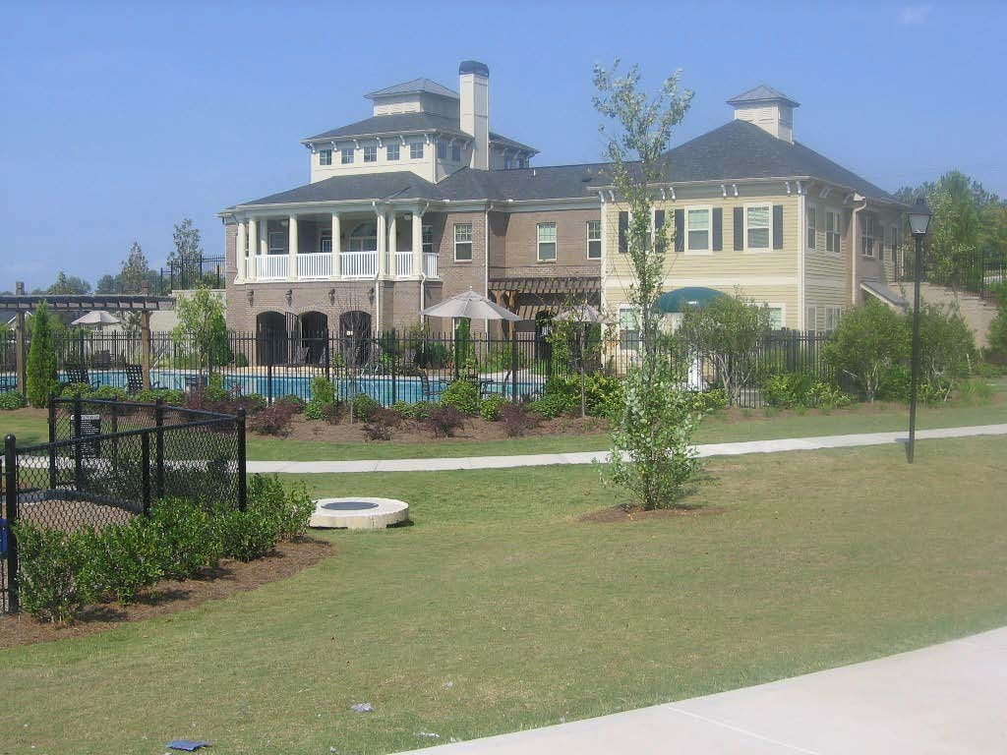
Acceptable Community Building Exterior

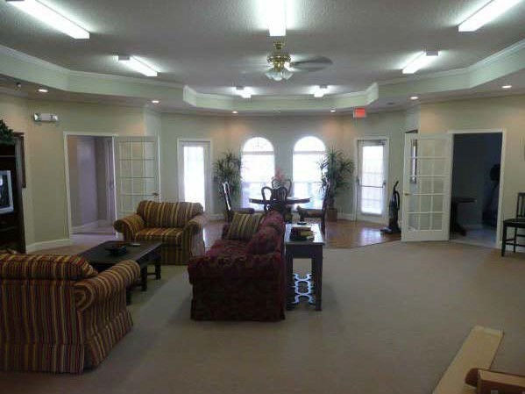
Acceptable Community Room Interior

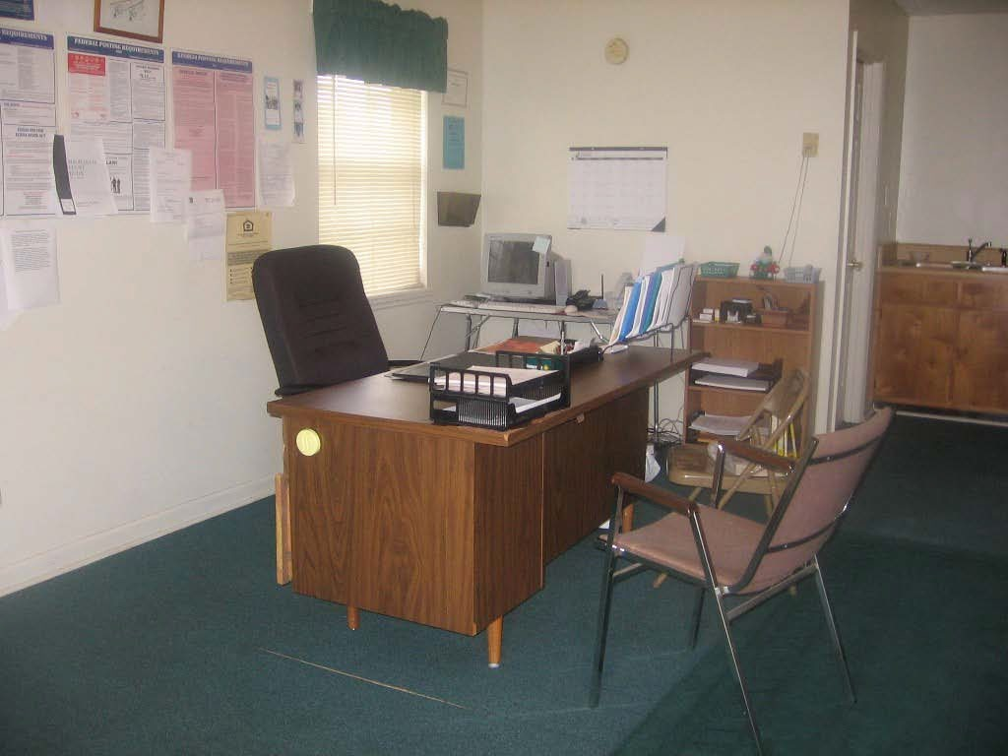
Not Acceptable Community Room Interior

The property manager’s office must be separate from the community room.

Exterior Gathering Area
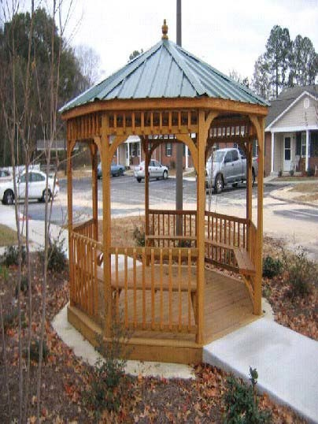
Acceptable

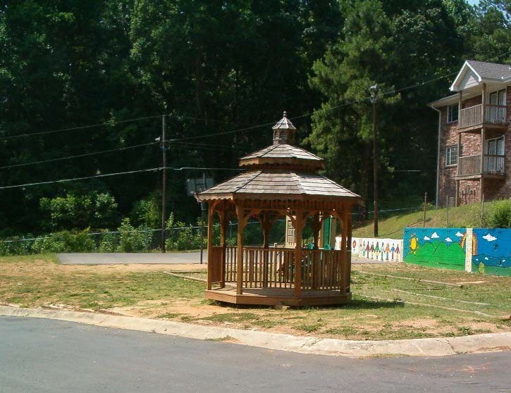
Not Acceptable

The gazebo is not permanently set, has no landscaping, and no accessible path.

On-site Laundry Facility or Washers/Dryers installed in each unit
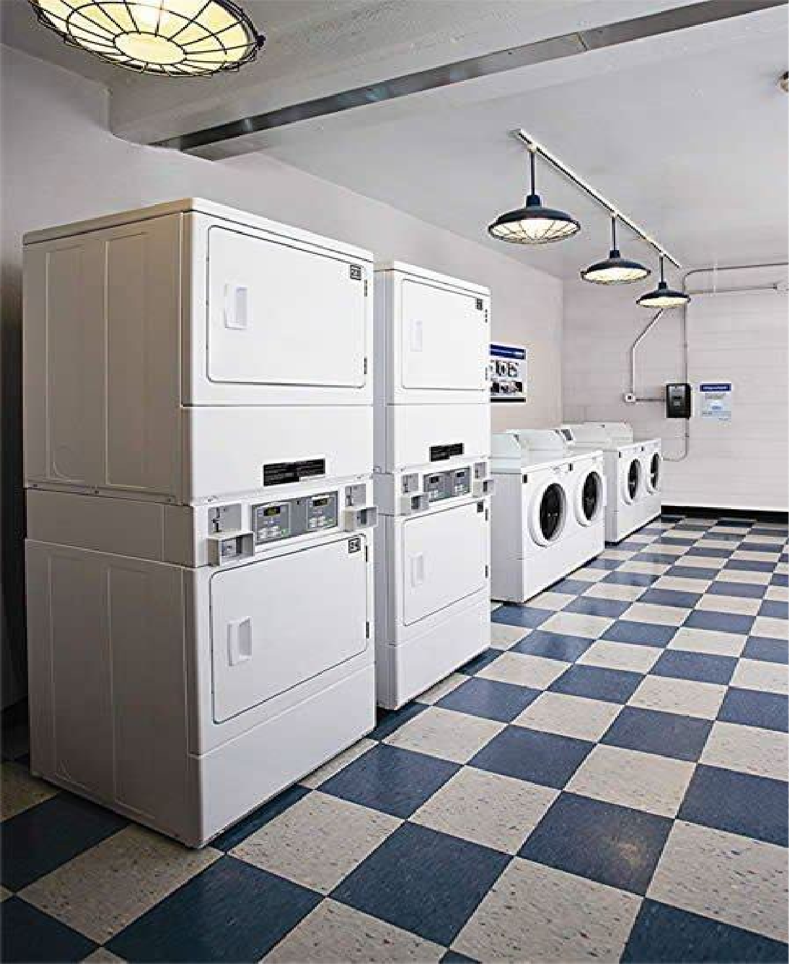
Acceptable

Note the front-loading machine at right.

Interior Furnished Gathering Areas (Senior Only)
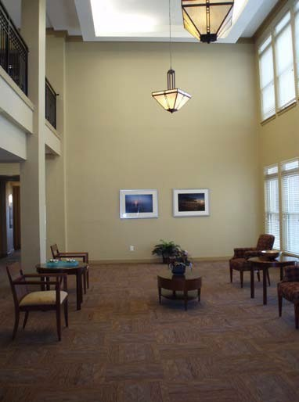
Acceptable

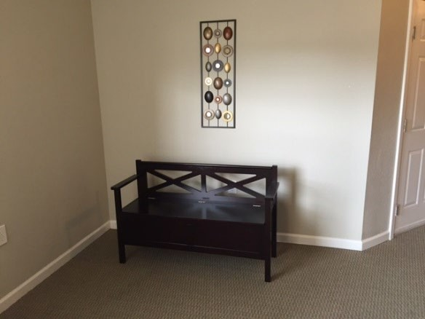
Not Acceptable

(No table or task lighting)

ADDITIONAL AMENITIES

Attractively Fenced Community Garden

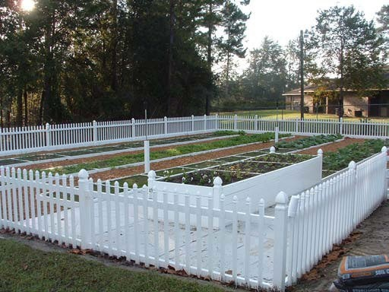
Acceptable
The garden beds are elevated to an accessible height, each plot has a water source, and the plots are on an accessible path.
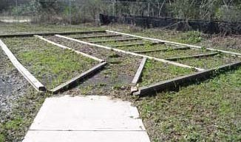
Not Acceptable
No fence; overgrown with weeds.

Equipped Playground
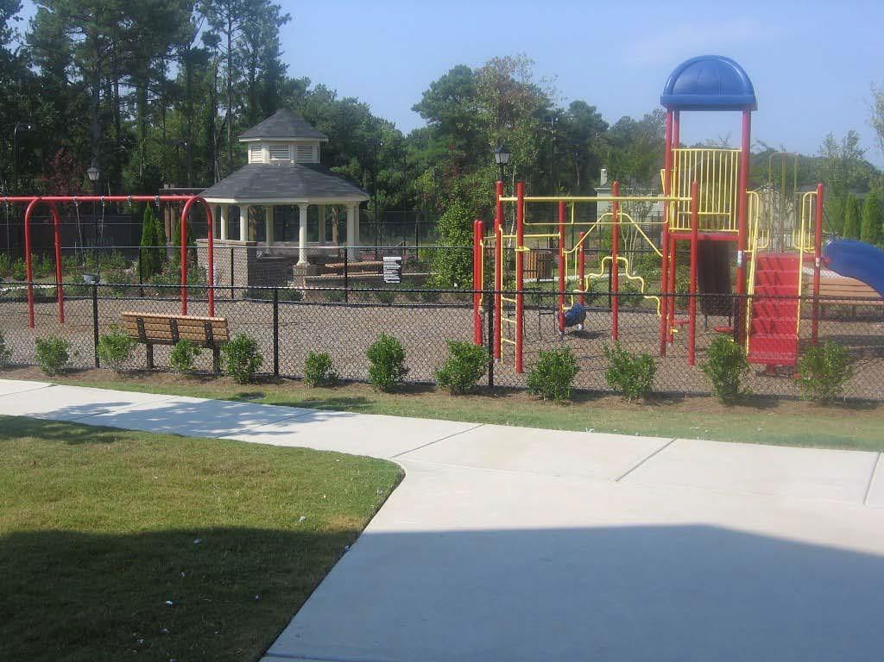
Acceptable
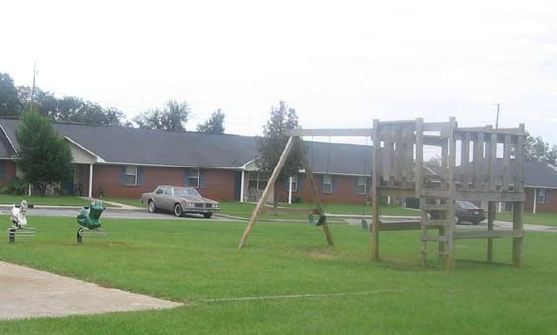
Not Acceptable
Equipment not constructed in compliance with CPSC guidelines for materials, ladder handrails, or ground cover. There is no observation bench.

Covered pavilion with picnic/barbecue facilities
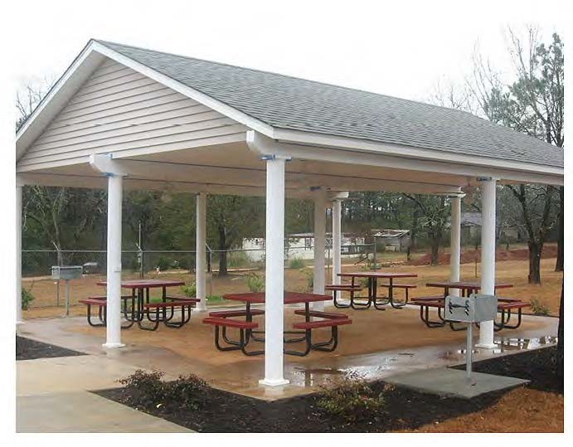
Acceptable
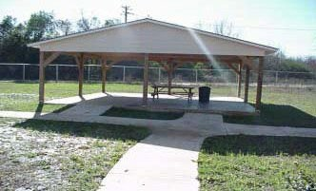
Not acceptable

The pavilion structure is borderline permanent, weatherproof structure. There are no grills, there are not enough picnic tables, and the absence of landscaping makes the pavilion appear uninviting.

Furnished Children’s Activity/Seniors Craft Center
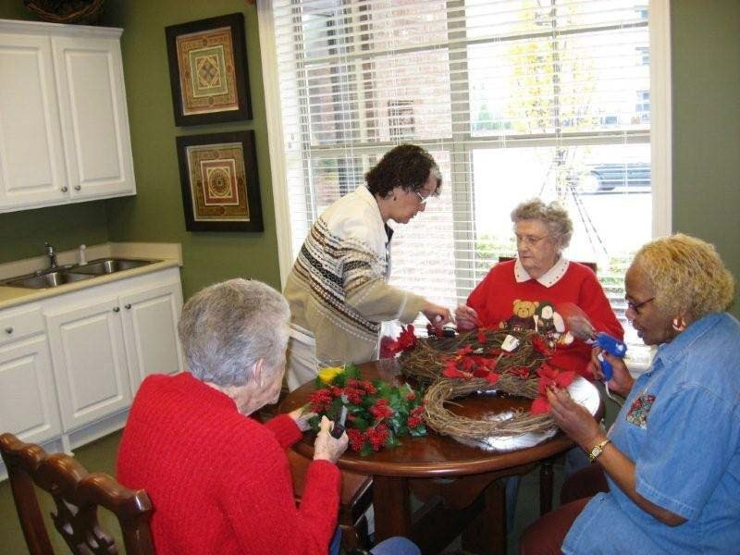
Acceptable
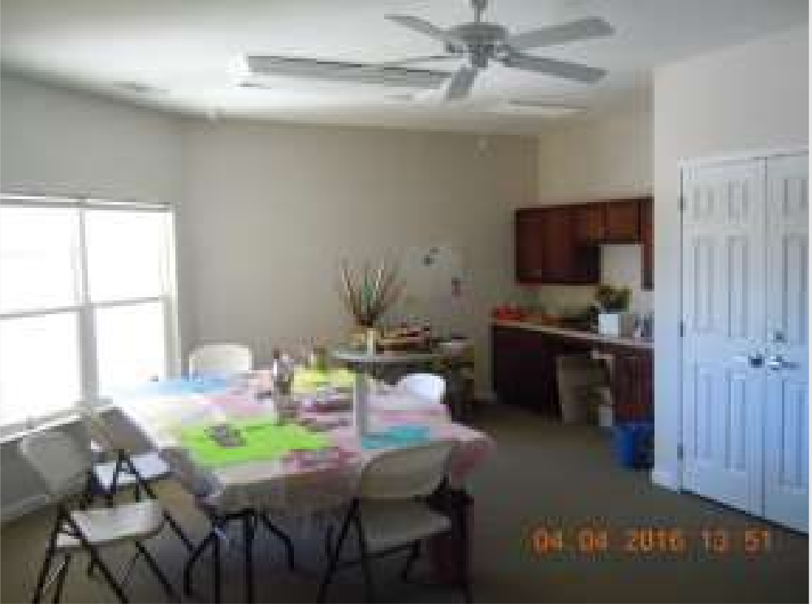

Not Acceptable
(Uninviting room without decorations and use of folding furniture and table)

Computer Center
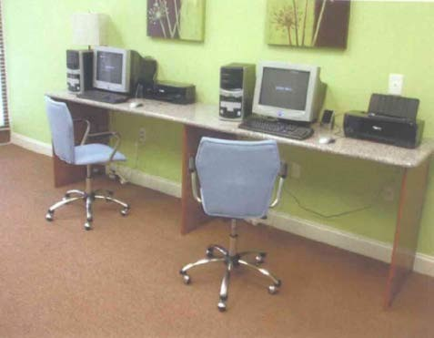
Acceptable
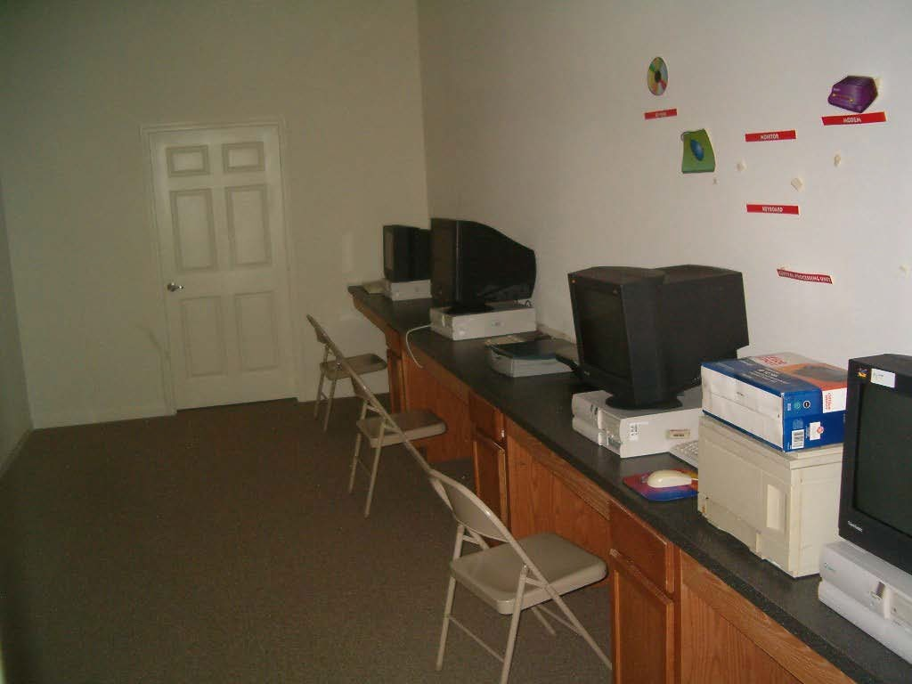
Not acceptable

Folding chairs are not acceptable. Equipment should be new; the condition of this equipment is questionable.

Furnished Exercise / Fitness Center
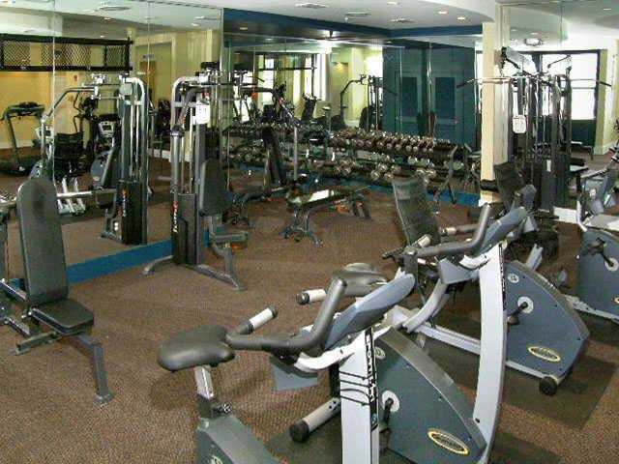
Acceptable
There is a variety of commercial grade equipment, cardiovascular equipment rests on slip-resistant mats, and the room is mirrored.
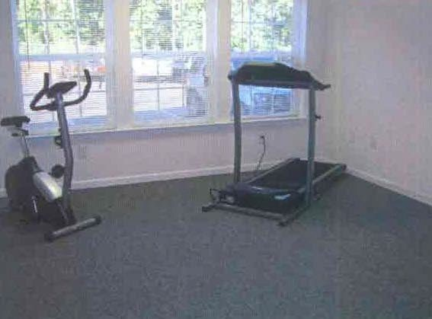
Not Acceptable
Equipment is used and not commercial grade.
There is not enough equipment for the size of the complex.

Wellness Center
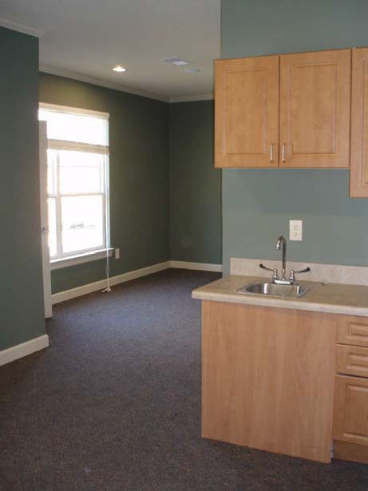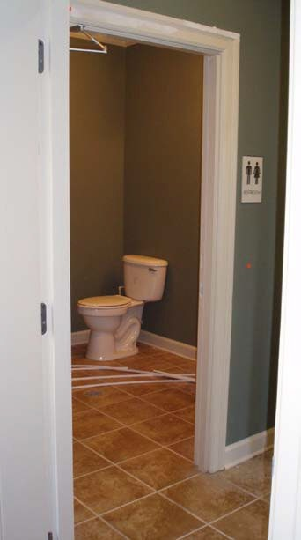

Not Acceptable

This Wellness Suite includes a prep sink, and exam area, a library waiting area and a bathroom that services the suite. The suite requires an exam table and furnished library with health literature to be acceptable.

